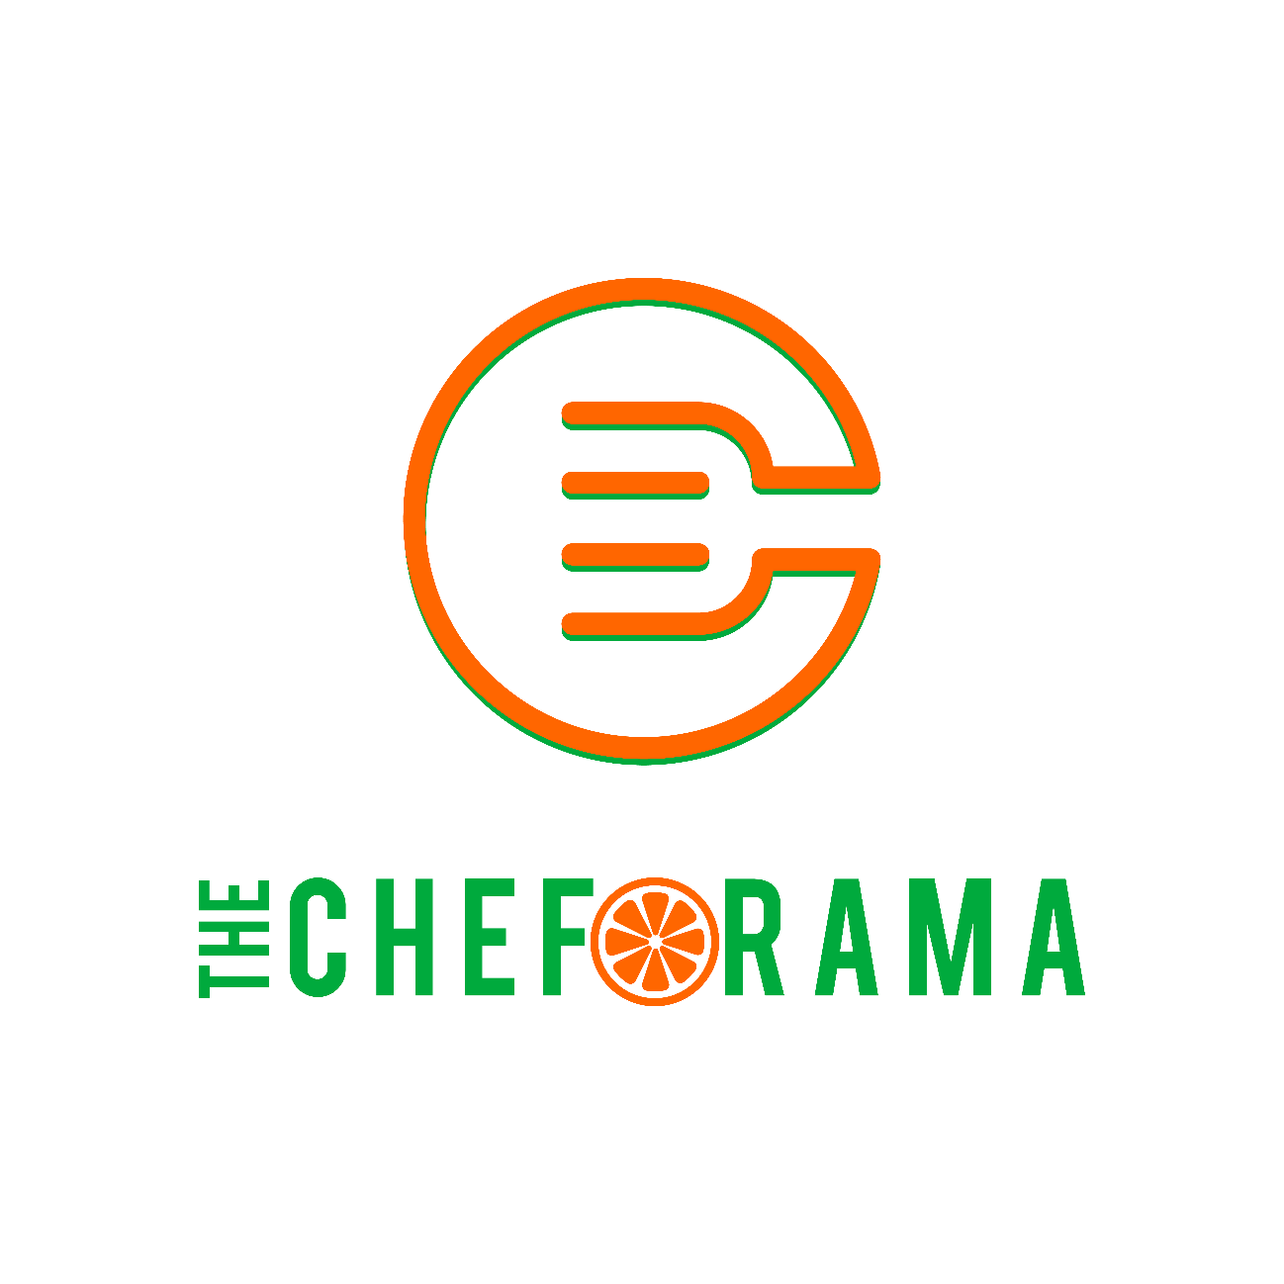
project FOUNDED: 10.10.2021
WHITEPAPER published :11.18.2021

Author: Suraj “Sunny” Chopra

INDEX

ABOUT US
- Symbol: $CHEF
- Project Website – www.thecheforama.com
PROJECT PARTNERS
- CHEF SURAJ “SUNNY” CHOPRA (Founder/CEO)
- AKSHAYE CHOPRA (Project Manager)
- SHAURYA VEER SINGH (Chief Technology Officer ‘CTO’)
- TULIKA BHARDWAJ (Chief Community Officer)
CHEFORAMA ($CHEF) TOKENOMICS
- Contract Address: 0x1C2fa543c4C39717B6d07450CE5AD328410a7696
- Blockchain: Binance Smart Chain
- Total Supply: 5.000.000.000
- 8% Transaction Fee < 2% RND – ecosystem development, 2% Community Outreach, 2% The cheforama Yacht Club, 2% marketing
TOKEN DISTRIBUTION

CHEFORAMA’S CONCEPTULISATION
If you asked any number of hospitality professionals about the challenges and obstacles, they have faced in the post-COVID-19 world, you might be surprised at the difficulties faced in recent years in running a farm, restaurant, hotel, country club, or catering business. To fully comprehend the scope of issues in this vast food service ecosystem, one must look beneath the glamorous world of food network chefs and starred restaurants to see how fractured the operational system is and how it is held together by a few champions doing their best to provide.
Did you know that on the entire North American continent, there are only two macro level dairy producing farms, and not long ago, one of them had a plant lose electricity. This led to a slight drop in milk output, which then actioned a domino effect and resulted in a country-wide ice cream shortage! The mainstream centralization of the food service sector economy has led to many huge brands maintaining a majority section of the supply chain ratio. This has impacted retail customers and ordinary households.
Although most of the 21st century restaurants and chefs have time and again reiterated the importance of local sourced food, studies still show that 68% of the north American household shops at their Favorite superstores (Walmart, stop n shop, star market etc.).
Here, decentralization comes as a solution which helps overcome this hurdle by giving the power back to the community. To further help the community in amplifying its voice, Cheforama acts as that decentralized ecosystem where each member of the food service community, from the farmer trying to access his soil’s carbon ratio to improve profitability to the Restaurant operator who can check in real time how his orders are processed and what his delivery timeframes are, can use the native currency $CHEF within all the multimedia and social partnerships. They can also take advantage of community outreach hubs where help is provided not just to enable technological advancements but also to ensure a humane work life balance and help the community prosper.

FOUNDING INITIATIVE
CHEFORAMA is a decentralized ecosystem on a bed of smart contracts induced tokenomics with a native cryptocurrency $CHEF.
Cheforama is a “by the community, for the community" ecosystem. We want to make sure that the community is thriving and progressing toward its objectives. All trading transactions will be subject to an 8% tax, which will be split into following:
2% RnD ecosystem development – 2% Community Outreach – 2% marketing - 2% the Cheforama yacht club
One of the major objectives of Cheforama is to help build a food service ecosystem where any willing participant of the community can reap the benefits of a fully decentralized ecosystem, where farmers can sell directly to the consumers, blockchain based logistics solution can acts as a remedy to the transportation hiccups, the Community outreach sector will develop an outreach program where the Food service community can learn to use the Ecosystem partnerships and community hubs such as NFT marketplace, Cheforama Yacht Club and other project partnerships.
Our goals include to work with food engineers, agricultural scientists, chefs, and sustainable restaurants to develop and improve farming solutions for humanity so that we will be able to have a sustainable farm on Mars when we reach the stage of space travel and establish multi-planet communities.
We will also engage with educational institutions to provide resources so that we can assist them in providing enough learning progression and opportunity to enable young talent to reach their full potential through The Cheforama Yacht Club hubs.

APPROACH
The Cheforama community will work based on a core team which will be led by a COO (chief operating officer) who will focus on defining the shape of the Cheforama community and making sure the community has all its needs met. A CBO (chief blockchain officer) will be the leading partner in developing the Cheforama ecosystem and will focus on establishing protocols for the Cheforama community to interact within itself, and a CCO (chief community officer) who will be responsible for the community outreach programs and set up outreach centers. The project manager will serve as the point of contact between the R&D and CO communities, as well as for establishing social and multimedia partnerships for the Cheforama community.
The sub committees will have leading teams that work on the direction towards providing the best product for the Cheforama community.
COMMUNITY GUIDELINES AND OPERATIONAL PROCEDURES
CHEFORAMA R&D COMMUNITY:
The R & D community will be focused on being a leading forefront partner in developing blockchain-based solutions. This will help shape the future of sustainable farming and establish micro-community food ecosystems and is intended to correct the imbalance that the hospitality sector is experiencing in the post-COVID-19 environment. The overall project is designed to provide the finest customer experience possible in the fast-expanding food service industry.
The R&D community sector will operate under a certain set of operational guidelines which will act as the core values of the community:

- R&D community will be led by a panel of seven industry leading professionals which will work in direct co-relation with CBO in developing technological advancements

- R&D community panel will be elected by a voting method on which all the active users of $CHEF can vote

- Community panel will be responsible for the community wallet and its transactions will be integrated with smart contracts which will be subject to vote by the Cheforama Community

- Any member of the Cheforama community can anytime choose to contest a dispute to any transaction or action of the R & D panel with their synopsis and a community vote will decide the outcome

- The R & D community will allocate its tax in the following sectors:
- 2% to be allocated the cheforama Ecosystem development where we will focus on bringing more and more additions to us such as $CHEF rewards program, $CHEF payment method integration, ‘WE-CHEFS – NFT marketplace’. Cheforama will also focus on brining blockchain based farming solutions to a micro farm while advancing the AI farming and blockchain based hiring solutions, to ease labor workforce crunch.

- 2% to be allocated for the initial development of ‘The Cheforama Yacht Club’ which will be a virtual hub for the community to partake in and enjoy its features.

CHEFROAMA COMMUNITY OUTREACH:
Cheforama community outreach sector will be responsible for working alongside the Cheforama mission statement to help rebuild the backbone of the Food Service Community, i.e., "THE PEOPLE."
The community will also collaborate closely with trade schools to help them implement advanced learning platforms to introduce modernist techniques and help develop neo gastronomy, we aim to help an emerging base of “Cana-chefs” in rolling out a new sector of cannabis restaurants.
The community outreach sector will operate under a certain set operational guidelines which will act as the core values of the community:
- The community will be led by a team of CCO (chief community officer) and the Project Manager who will work with a team of community officers which are in different demographic locations and are contributing to the community outreach programs and establish a community stronghold.

- The team will be responsible for the community wallet and its transactions will be deployed with smart contracts subject to a community vote to all active users of $CHEF

- Any member of the Cheforama community can anytime choose to contest a dispute to any transaction or action of the C.O panel with their synopsis and a community vote will decide the outcome

- The community outreach sector will use the 2% tax on the following sectors:
  - 1% will dedicated to build partnerships with educational institutions and helping young professionals get access to a better resource pool.
  - 1% will be dedicated to monthly charities, community partnerships with existing NGO’s and help strengthen the outreach programs.

CHEFORAMA ROADMAP
Q4 2021

Q1 2022

Q2 2022

Q3 2022

